

**RF4 – Series**

**4 Pole Permanent Magnet Alternators**

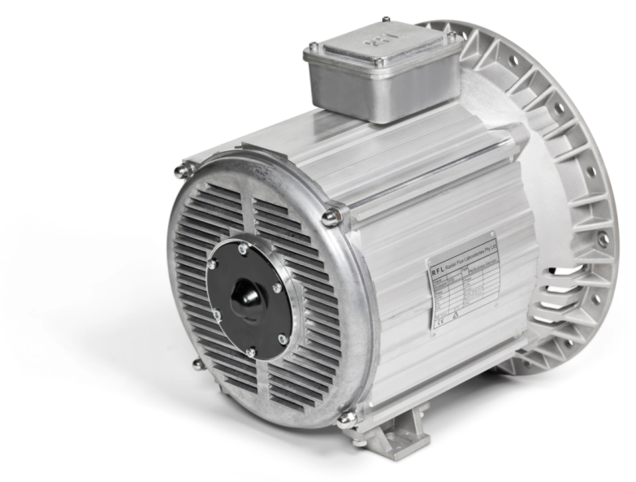

**Installation and Maintenance Manual**

2/7 Pritchard Pl,

Peakhurst, NSW, 2210

Phone: +61 2 9584 9970

**Radial Flux Laboratories Pty. Ltd.**

**E-mail:**[**sales@rflalternators.com**](mailto:sales@rflalternators.com)

**Web:** [**http://www.rflalternators.com/**](http://www.rflalternators.com/)

2/7 Pritchard Pl,

Peakhurst, NSW, 2210

Phone: +61 2 9584 9970

Mobile: +61 408 504 842

**Radial Flux Laboratories Pty. Ltd.**

**E-mail:**[**info@radialfluxlabs.com**](mailto:info@radialfluxlabs.com)

**Web:** [**http://www.rflalternators.com/**](http://www.rflalternators.com/)

Contents

Introduction 3

Inspection 4

Identification 4

Pre-installation 5

Installation 6

Maintenance 9

Electrical Connections 13

Dismounting the Alternator 14

Mechanical Characteristics 14

## Introduction

**The RFL RF4 SERIES of alternators is a breakthrough in 4 pole synchronous alternator design. The patented rotor design combines permanent magnets with reluctance to overcome the limitations of other permanent magnet synchronous alternator designs.**

**Characteristics**

* **Full Permanent Magnet Rotor, no windings on rotor, no rotor losses.**
* **IP 23 Mechanical Protections.**
* **Temperature specifications: tested in ambient temperature range of -10°C to 40°C**
* **Very high efficiency >94%.**
* **Excellent THD, <3%, no transients, no voltage spike on load rejection.**
* **Small footprint and lightweight.**
* **Reduced size.**
* **No electronics, increased reliability and robustness. Easy to fit and maintain.**
* **Bearing is the only wearing component (can be replaced without removing alternator from drive or disassembling).**

**Advantages**

**Unbalanced 3 Phase loads – The RF4 series alternator can supply 3 x 1 Phase circuits with varying loads, as well as a 3 phase load at the same time.**

**Motor Start capability – The Tri-Gen Generator can start single phase motors as well as 3 phase motors.**

**Paralleling generators – The Tri-Gen patented rotor allows a much wider out of phase angle over which they will lock together without high surge currents and shaft shock. This feature allows a number of smaller generators to be used to supply large loads with no special switching equipment.**

**Adjustable location of feet, bottom and side mounting options – The mounting legs can be relocated linearly to a desired position by loosening the bolts and sliding the mounting leg along the casing body as shown below. Refasten the leg bolts before mounting the alternator.**

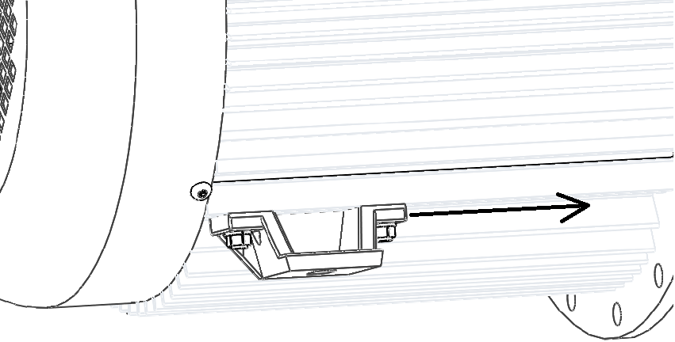

Figure 1 - Feet mounting can be adjusted along the length of the unit

**Before performing any operations with this alternator, it is highly recommended to read this manual for handling, installation and maintenance in its entirety. Maintenance and repairs should be performed by a qualified technician.**

**Technical support can be provided by contacting Radial Flux Laboratories at sales@rflalternators.com**

## Inspection

**Upon receiving of the alternator, check that no damage has occurred during transit. Ensure that there are no loose items inside the fan cover and all fasteners are tightly secured. Do not use the fan to turn the rotor before the alternator is mounted onto the engine. Doing so will cause rubbing and possible damage. If any damage is clearly visible, please contact us before installing this machine.**

**The RF4 alternator series should be stored at standard room temperature conditions free from dust and sediments. Keep away from vibration where possible. The IP casing design of the alternator resists moisture, however, permanent exposure to a moist environment during storage is not recommended.**

**The RFL alternator series is designed to generate single phase and 3 phase electricity. Voltages can be customised before manufacturing and is fixed at the factory during winding to suit applications**

## Identification

**All RFL alternators can be identified by the name plate fixed to the body of the machine. Check that the name plate information conforms to the ordered model. Before installing the alternator, check that the rated voltage, frequency and power are correct.**

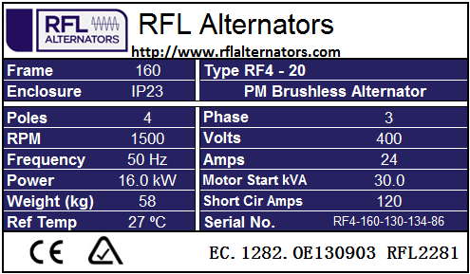

Figure 2 - Name plate information for 4 Pole units

## Pre-installation

**Before installing the alternator, it is important to remove the grease on the taper surfaces on both the Taper Shaft Coupling** ① **piece and inside the rotor shaft** ②**. The protective anti-rust grease is applied during manufacturing to protect the alternator during storage and transit and must be removed to ensure a solid lock on the taper. DO NOT USE LUBRICATION ON THIS SURFACE. The taper is friction driven and MUST be clean before fitting.**

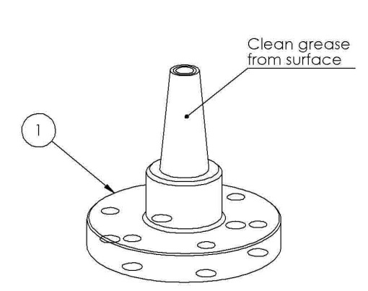

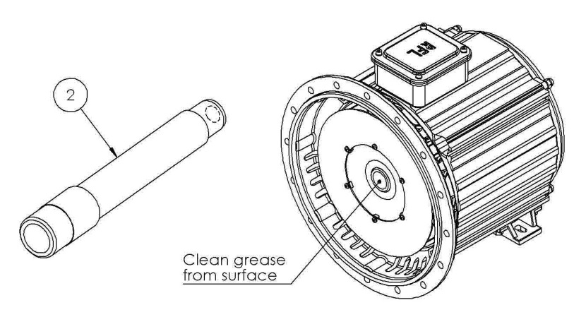

## Installation

**Before mounting this machine to the engine, care must be taken to ensure that the cooling air intake through the grill of the alternator is clear and unhindered. It is highly recommended to divert both hot air and exhaust air from the engine away from the air intake of the alternator to maximise cooling.**

**Whilst the mounting legs can be taken off and relocated in various configurations on the casing body, ensure care is taken to locate any drain plugs/holes on the lowest point of the alternator.**

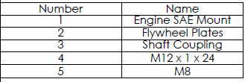

**The above parts are required to perform steps to a correct alternator attachment to the engine mount. Please identify all parts before proceeding.**

0

1. **Prepare 3/8 UNF Bolts for the SAE Engine Housing Mount** ①**. Note the number of bolts and bolt sizes varies depending on the SAE engine housing number and engine model.**

**For SAE6 and SAE5 Housing, there are 8 tapped holes**

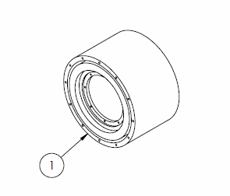**For SAE4 and SAE3 Housing, there are 12 tapped holes**

0

1. 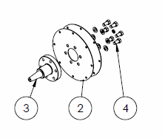**Bolt the Taper Shaft Coupling** ③ **piece to the 2pcs Flywheel Plates** ② **using the 6pcs M12 Bolts** ④**. M12 spring washers under the bolt heads are recommended.**
2. **Bolt the now combined Taper Shaft Coupling and Flywheel Plates to the Engine SAE Mount. These are usually M8 bolts** ⑤ **but can vary between engine models and are not supplied. Spring washers under the bolt heads are recommended.**

0

fdfd

Fs

fdsdf

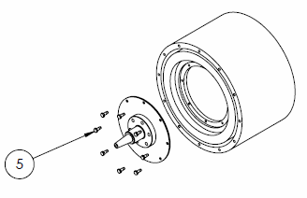

0

fdfd

Fs

fdsdf

1. **The RFL alternator** ① **is now ready to be mounted to the engine. It is recommended lifting the alternator into position in front of the engine using a crane and eye bolts that can be fastened to the casing body with a nut inside the body casing in the same fashion as the feet mounts.**

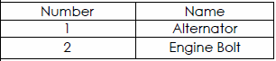

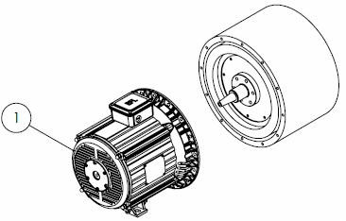

1. **Add a standard washer and a high tensile spring washer (both supplied) onto the Engine Bolt** ② **and insert the Engine Bolt into the central shaft of the alternator. Tighten using a torque wrench to lock the rotor onto the Taper Shaft Coupling. Torque wrench tensions for various models are shown below.**

0

Fs

fdsdf

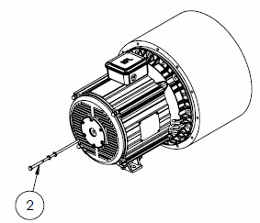

|  |  |
| --- | --- |
| Model Number | Engine Bolt Tension (N.m.) |
| RF4 – 10 | 50 |
| RF4 – 20 | 50 |
| RF4 – 30 | 60 |
| RF4 – 40 | 60 |

0

1. **Bolt the alternator flange to the Engine SAE Housing using 3/8 UNF Bolts. Using rubber vibration dampeners to support the feet mounts of both the engine and the alternator. Note that the RF4 – 10 and RF4 – 20 models are able to support themselves via the flange bolts and can be mounted without legs, provided the engine does not require support from the alternator feet mounts.**

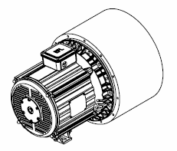

## Maintenance

**The RFL Alternator is designed such that the bearing is the only point of failure during its operational life. The bearing can be removed and replaced without removing the alternator from the engine. The following steps for replacing the bearing are done while the alternator is still mounted to the engine.**

**A bearing kit is required to pull the bearing housing from the back end and to insert a new housing with bearing onto the rotor shaft. It is recommended that the bearing must be changed every 3,000 Hours of running. A bearing kit consists of the following parts:**

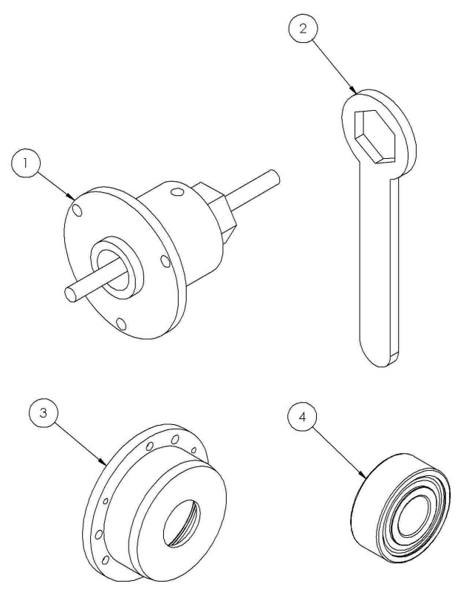

|  |  |
| --- | --- |
| ① | **Bearing Remover** |
| ② | **Ring Spanner** |
| ③ | **Bearing Housing** |
| ④ | **Bearing (62306_2RS1)** |
| ⑤ | **3 x M8 Bolts** |

**The above parts are packaged as a bearing kit, and can be ordered from RFL. Please identify and ensure all parts arrive in good condition before proceeding with the bearing replacement.**

1. **Unfasten all six bolts from the bearing cover at the back end of the alternator and remove the original black bearing cover and put in a clean area, it will be reused at the final step.**

0

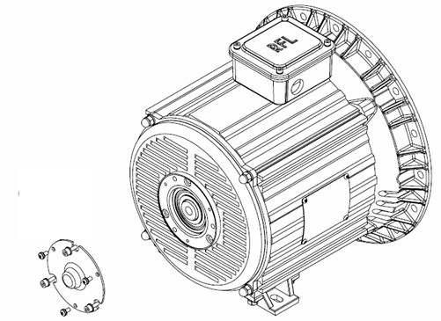

0

1. **Direct the threaded rod portion of the Bearing Remover** ① **tool into the centre hole of the shaft and screw the Bearing Remover into the central rotor shaft until the flat bottom of the tool makes contact with the bearing housing. Align the Bearing Remover until the M8 holes line up with the holes in the bearing housing, and bolt it down with the 3xM8 bolts** ⑤**. Washers under the bolt heads are highly recommended before proceeding to the next step.**

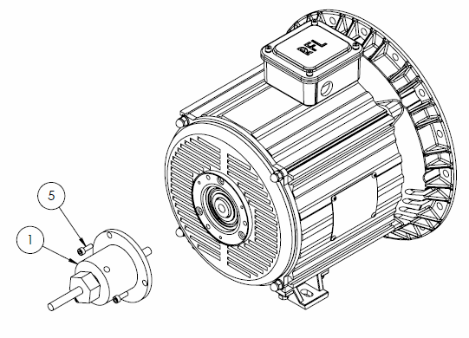

1. **Use the Ring Spanner** ② **to turn the hexagon head clockwise. The bearing housing will slowly begin to lift off the end cap. Continue turning the spanner until the bearing housing is completely removed and unfasten the 3xM8 bolts. The old bearing and bearing housing can be discarded.**

0

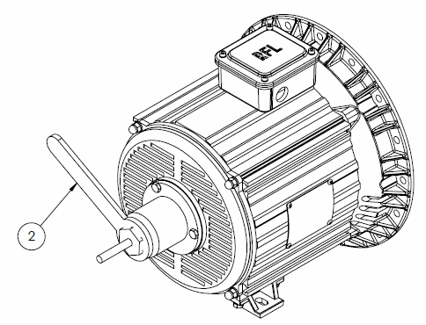

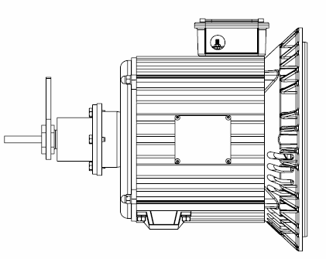

**Note: Turning the Ring Spanner can require some force if the alternator unit is old. If this is the case, ensure that the threaded rod of the Bearing Remover is further down into the shaft as it allows the thread to be able to tolerate larger forces.**

1. **Arrange the new bearing** ④**, bearing housing** ③ **and Bearing Remover** ① **tool in the configuration shown below to insert the new bearing parts onto the rotor shaft. In a similar fashion to removing the bearing, screw plenty of the threaded rod into the shaft for strength, and turn the spanner anti-clockwise until bearing is up to the shoulder on the shaft. Ensure the holes on the bearing housing line up with the appropriate holes on the back end cap of the alternator as bearing tool pushes the housing in. Once the bearing housing is completely sitting on the end cap of the alternator, bolt the 3 x M8 bolts on, and replace the original black bearing cover from the first step.**

0

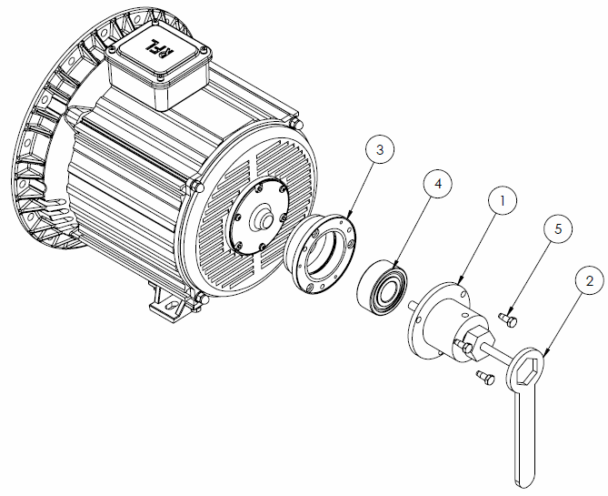

|  |  |
| --- | --- |
| ① | **Bearing Remover** |
| ② | **Ring Spanner** |
| ③ | **Bearing Housing** |
| ④ | **Bearing (62306_2RS1)** |
| ⑤ | **3 x M8 Bolts** |

## Electrical Connections

**The RFL alternators can be connected in Y-Connection to produce 3-Phase output or in Δ-Connection to produce Single-Phase output. Adjust the position of the brass bridge connector to one of two configurations shown below to suit the required electrical output.**

0

**Y-Connection for 3-Phase output**

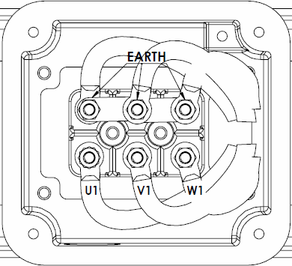

**Neutral**

0

**Δ-Connection for Single-Phase output**

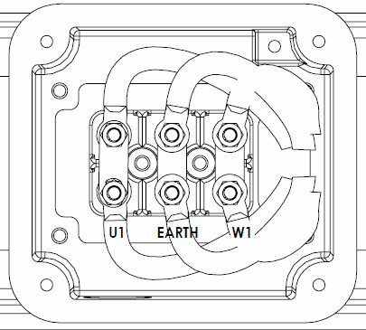

**V1**

## Dismounting the Alternator

**The RFL alternator is specially designed to allow the bearing unit to be serviceable while remaining mounted to the engine, thus eliminating the need to dismount the alternator from the engine. For cases where dismounting the alternator is required, please contact RFL directly for instructions on correct alternator dismount procedures. Dismounting the alternator without contacting RFL beforehand may void the warranty.**

## Mechanical Characteristics

0

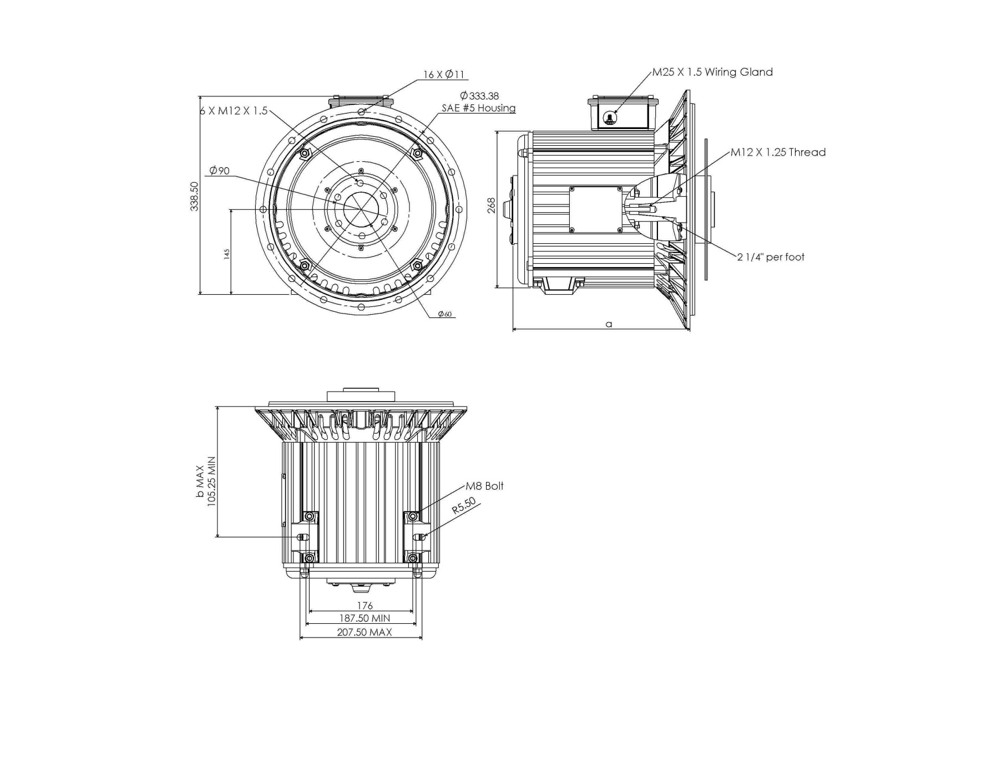

|  |  |  |  |
| --- | --- | --- | --- |
| **Model** | a | b | Weight |
| mm | mm | kg |
| **RF4-10** | 236 | 189 | 39 |
| **RF4-20** | 301 | 223 | 58 |
| **RF4-30** | 351 | 273 | 77 |
| **RF4-40** | 421 | 343 | 96 |