

**RF2 – Series**

**2 Pole Permanent Magnet Alternators**

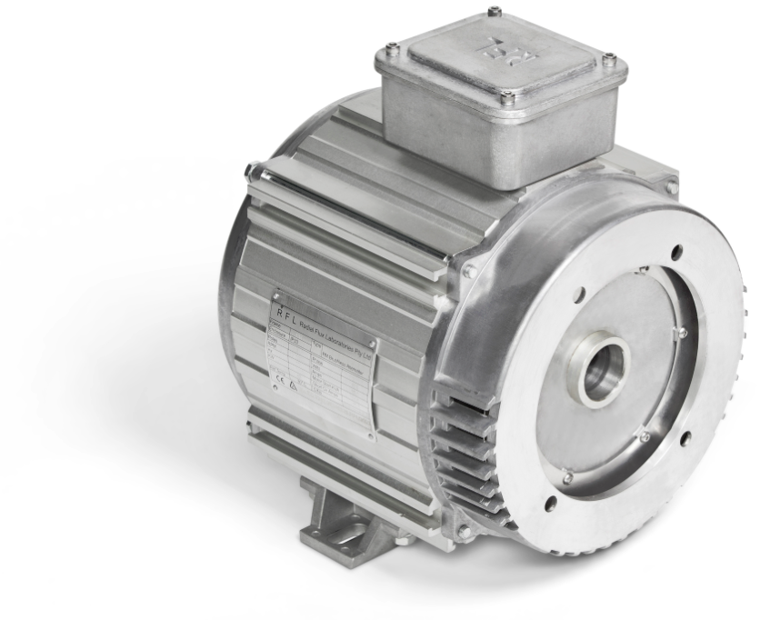

**Installation and Maintenance Manual**

15 Waltham St,

Artarmon, NSW, 2064

Phone: +61 2 9584 9970

**Radial Flux Laboratories Pty. Ltd.**

**E-mail:**[**sales@rflalternators.com**](mailto:sales@rflalternators.com)

**Web:** [**http://www.rflalternators.com/**](http://www.rflalternators.com/)

2/7 Pritchard Pl,

Peakhurst, NSW, 2210

Phone: +61 2 9584 9970

Mobile: +61 408 504 842

**Radial Flux Laboratories Pty. Ltd.**

**E-mail:**[**info@radialfluxlabs.com**](mailto:info@radialfluxlabs.com)

**Web:** [**http://www.rflalternators.com/**](http://www.rflalternators.com/)

Contents

Introduction 3

Inspection 4

Identification 4

Pre-installation 5

Installation 6

Electrical Connections 9

Mechanical Characteristics 10

Dismounting the Alternator 11

## Introduction

**The RFL RF2 SERIES of alternators is a breakthrough in 2 pole synchronous alternator design. The patented rotor design combines permanent magnets with reluctance to overcome the limitations of other permanent magnet synchronous alternator designs.**

**Characteristics**

* **Full Permanent Magnet Rotor, no windings on rotor, no rotor losses.**
* **IP 23 Mechanical Protection.**
* **Temperature specifications: tested in ambient temperature range of -10°C to 40°C**
* **Very high efficiency >92%.**
* **Excellent THD, <3%, no transients, no voltage spike on load rejection.**
* **Small footprint and lightweight.**
* **Reduced size.**
* **No electronics, increased reliability and robustness. Easy to fit and maintain.**
* **Bearing is the only wearing component**
* **PTO V-type shaft mounting**

**Advantages**

**Unbalanced 3 Phase loads – The RF2 series alternator can supply 3 x 1 Phase circuits with varying loads, as well as a 3 phase load at the same time.**

**Motor Start capability – The Tri-Gen Generator can start single phase motors as well as 3 phase motors.**

**Paralleling generators – The Tri-Gen patented rotor allows a much wider out of phase angle over which they will lock together without high surge currents and shaft shock. This feature allows a number of smaller generators to be used to supply large loads with no special switching equipment.**

**Adjustable location of feet, bottom and side mounting options – The mounting legs can be relocated linearly to a desired position by loosening the bolts and sliding the mounting leg along the casing body as shown below. Refasten the leg bolts before mounting the alternator.**

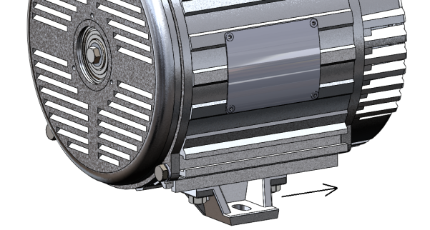

Figure 1 - Feet mounting can be adjusted along the length of the unit

**Before performing any operations with this alternator, it is highly recommended to read this manual for handling, installation and maintenance in its entirety. Maintenance and repairs should be performed by a qualified technician.**

**Technical support can be provided by contacting Radial Flux Laboratories at sales@rflalternators.com**

## Inspection

**Upon receiving of the alternator, check that no damage has occurred during transit. Ensure that there are no loose items inside the fan cover and all fasteners are tightly secured. Do not use the fan to turn the rotor before the alternator is mounted onto the engine. Doing so will cause rubbing and possible damage. If any damage is clearly visible, please consult RFL before installing this machine.**

**The RF2 alternator series should be stored at standard room temperature conditions free from dust and sediments. Keep away from vibration where possible. The IP casing design of the alternator resists moisture, however, permanent exposure to a moist environment during storage is not recommended.**

**The RFL alternator series is designed to generate single phase and 3 phase electricity. Voltages can be customised before manufacturing and is fixed at the factory during winding to suit applications.**

## Identification

**All RFL alternators can be identified by the name plate fixed to the body of the machine. Check that the name plate information conforms to the ordered model. Before installing the alternator, check that the rated voltage, frequency and power are correct.**

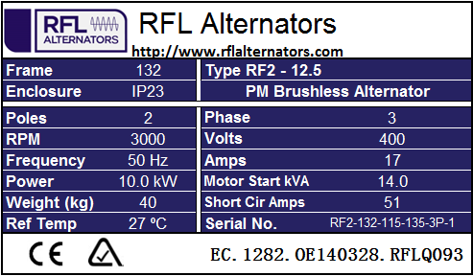

Figure 2 – Example name plate information for 2 Pole units

## Pre-installation

**Before installing the alternator, it is important to remove the grease on the taper surface inside the rotor shaft, and any existing grease on the engine V-type taper shaft. The protective anti-rust grease is applied during manufacturing to protect the alternator during storage and transit and must be removed to ensure a solid lock on the V-type taper shaft.**

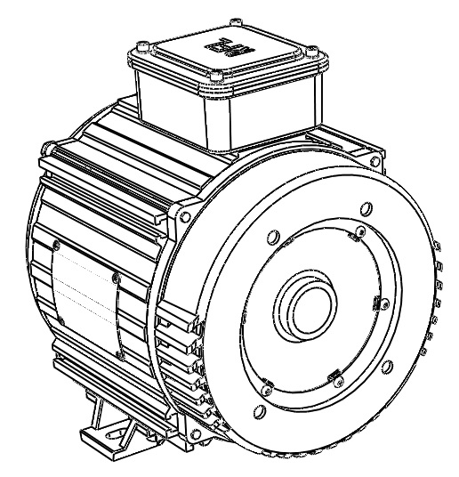

Clean residue grease

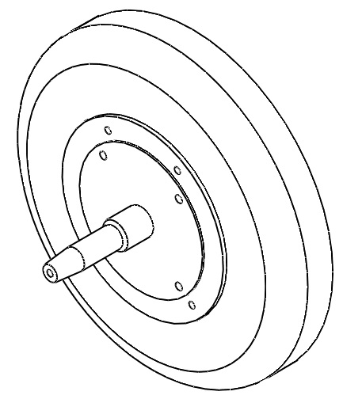

Clean residue grease

## Installation

**Before mounting this machine to the engine, care must be taken to ensure that the cooling air intake through the grill of the alternator is clear and unhindered. It is highly recommended to divert both hot air and exhaust air from the engine away from the air intake of the alternator to maximise cooling.**

**Whilst the mounting legs can be taken off and relocated in various configurations on the casing body, ensure care is taken to locate any drain plugs/holes on the lowest point of the alternator.**

|  |  |
| --- | --- |
| **Part Name** | **Number** |
| 5/16 UNF Engine Bolt | ① |
| 5/16 Washer | ② |
| 5/16 Spring Washer | ③ |
| 4 x 5/16 x 24 UNF Socket Flat head Bolt | ④ |

**The above parts are required to perform steps to a correct alternator attachment to the engine mount. Please identify all parts before proceeding.**

0

1. **Unbolt the 4 casing bolts and remove the Casing Flange from the casing body as shown. Gentle taps with a soft hammer will loosen the fit between the two parts.**

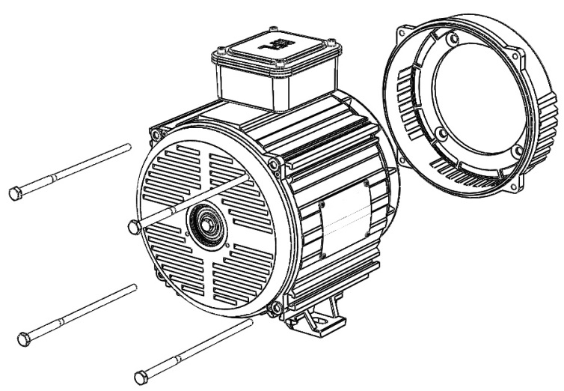

Casing Flange

0

1. 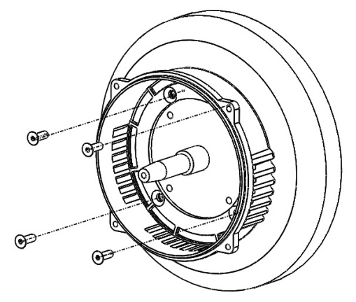**Fit the Casing Flange over the engine and align the holes. Use socket flat head bolts to fasten** ④

④

1. **Bolt the alternator unit back onto the Casing Flange using the four casing bolts and tighten. Ensure the holes on the feet mount align with the vibration dampeners.**

0

fdfd

Fs

fdsdf

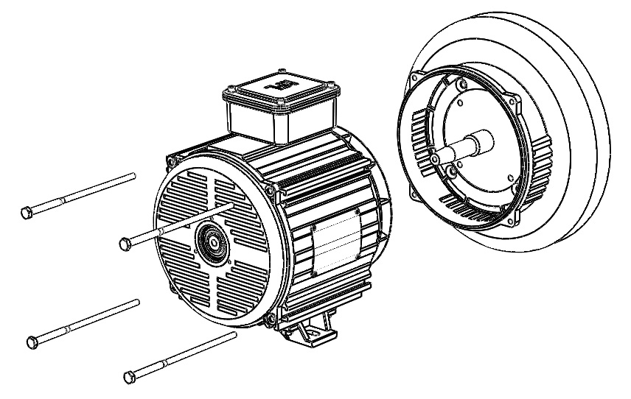

0

Fs

fdsdf

1. **The alternator is now ready to be taper-locked onto the engine shaft. Remove the bolt cap covering the rotor shaft and add the 5/16 washer** ② **and 5/16 spring washer** ③ **onto the 5/16 UNF bolt** ①**. Insert the bolt into the central rotor shaft of the alternator and tighten firmly. Hold the engine in place as the engine may begin to rotate as the bolt tightens by holding the manual pull start rope. If the engine has an electric start then the rotor of the alternator can be fixed by wedging a screwdriver into the side grill of the alternator and stopping the fan from turning. This will allow further tightening of the bolt, which firmly holds the alternator to the engine.**

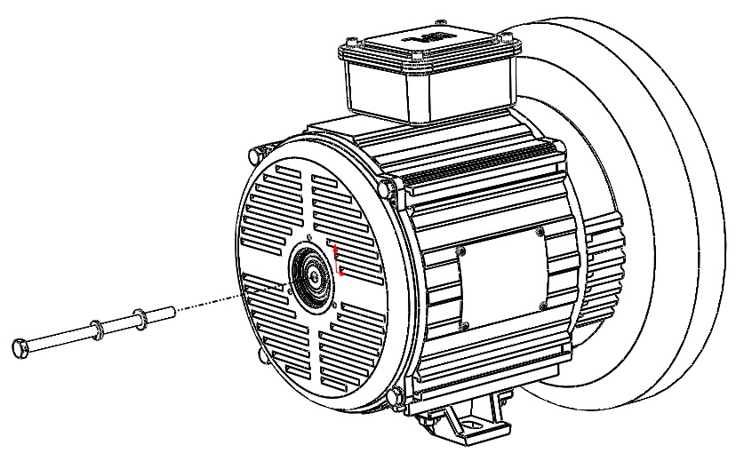

②

③

①

1. **Bolt the Bolt Cap back onto the end of the alternator to cover the spinning bolt head for safety purposes.**

0

Fs

fdsdf

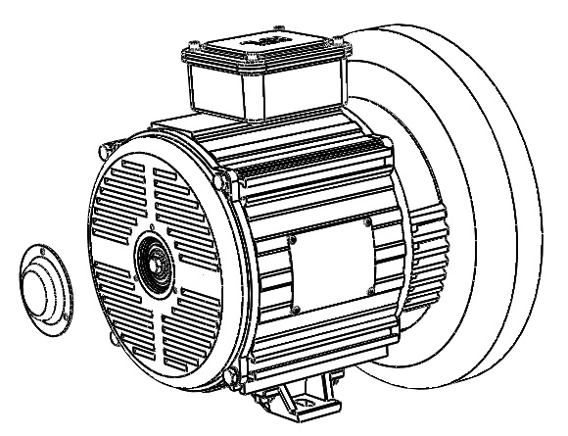

Bolt Cap

0

1. **Bolt down the feet mounts and complete electrical connections (see next page).**

## Electrical Connections

**The RFL alternators can be connected in Y-Connection to produce 3-Phase output or in Δ-Connection to produce Single-Phase output. Adjust the position of the brass bridge connector to one of two configurations shown below to suit the required electrical output.**

0

**Y-Connection for 3-Phase output**

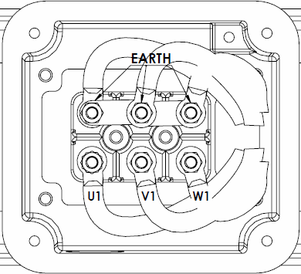

**Neutral**

0

**Δ-Connection for Single-Phase output**

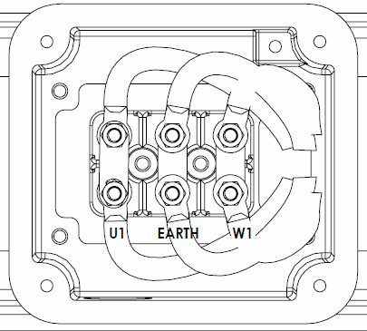

**V1**

## Mechanical Characteristics

0

|  |  |  |  |
| --- | --- | --- | --- |
| **Model** | a | b | Weight |
| mm | mm | kg |
| **RF2-7.5** | 192 | 189 | 28 |
| **RF4-20** | 237 | 169 | 40 |
| **RF4-30** | 286 | 219 | 51 |

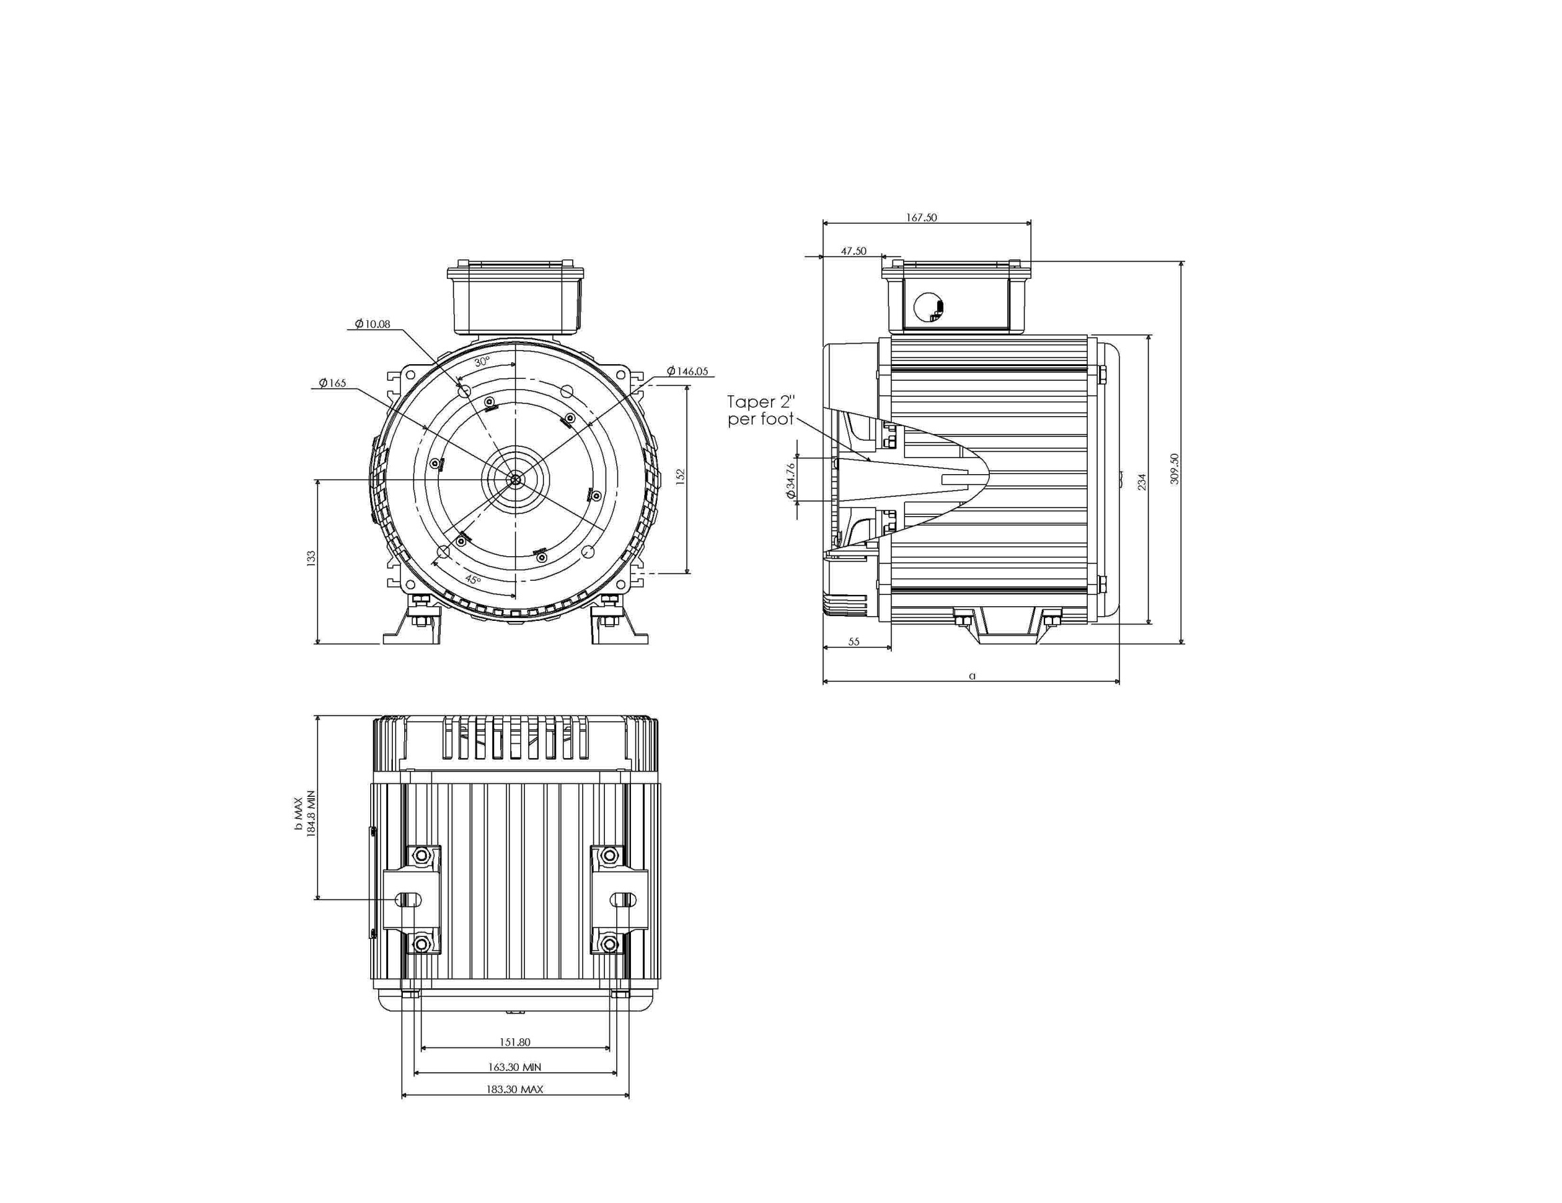

## Dismounting the Alternator

**RFL Alternators are designed to maximise service life by minimising wearing parts.**